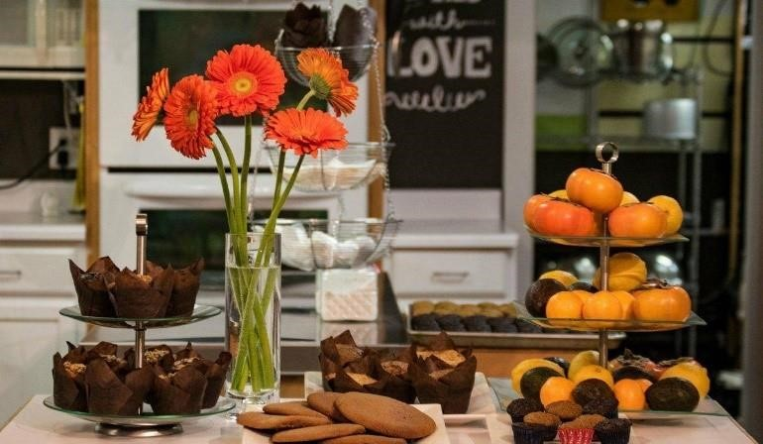

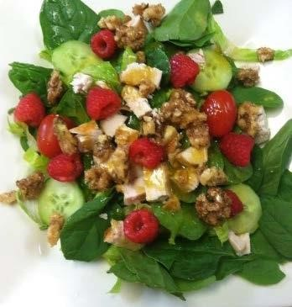

Salads
Organic Spinach & Berry………………….13.54
Spinach, Seasonal Berries, Cucumber, Feta, & Candied Walnuts. Drizzled with our Balsamic Dressing.
Vegan Caesar……………………………………… 11.78
Organic Greens with Cucumber & G.F. Croutons.
Topped with our Nut Free Vegan Caesar Dressing.
ADD CHICKEN……….3.00
Albacore Tuna Salad…………………………14.48
Albacore Tuna, with –or– without Mayo, on a bed of Organic Greens with Cucumber & Tomato. Topped with our Lemon Dressing.
Turkey Taco Salad…………………………..…15.62
Seasoned ground Turkey on a bed of organic greens. Topped with Jalapeno, Olives, Tomato, Salsa &
G.F. Organic Tortilla Chips.
WRAP IT UP! $1 CHARGE TO PUT SALADS IN A WRAP!

Soups
G.F./Vegan Organic Broccoli Soup Cup..…8.25 - or - Bowl…..10.64
Served with Organic Sweet Potato Crackers & Fresh Fruit
Soup Du Jour
Ask about our soup of the day
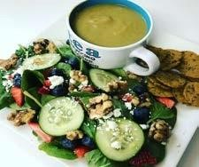

Sandwiches & Wraps
Served on G.F. or Organic Bran Bread…
Spinach Wrap OR Wheat.– Add $1.00
Served with chips & Fresh Seasonal Fruit
Egg Salad…………………………..……………….12.72
Egg Salad seasoned with Dijon, Mayo & Salt. Topped with tomato & organic spinach.
Albacore Tuna Sandwich………………..14.48
Albacore Tuna, with –or– without Mayo. Topped with tomato & organic spinach.
G.F. Turkey Vegetable Meatloaf………15.52
Ground Turkey loaded with vegetables. Topped with special sauce, tomato & organic spinach.
G.F. Turkey Pesto………………………………14.48
Natural Turkey Breast with our Artichoke Pesto.
Topped with tomato & organic spinach.
Vegan Hummus Wrap………………………13.94
Our fresh sundried tomato hummus wrapped with cucumber, tomato organic spinach and
Seasonal avocado.
(Not available in the ½ Sandwich Combo)

Combos
Soup with ½ Sandwich
Sandwich of your choice served with Fresh Fruit.
Cup..…14.01 - or - Bowl…..16.56
Soup with Full Sandwich
Sandwich of your choice served with Fresh Fruit.
Cup..…17.60 - or - Bowl…..19.67
Soup & Salad
Our Organic Berry Salad with Your Choice of Soup.
Cup..…15.52 - or - Bowl…..17.60
Sandwich & Salad
Our Organic Berry Salad with Your Choice of Sandwich.
½ Sandwich..…15.52 - or - Full…..17.60

Muffins
No Dairy, Oil, Butter, Soy or Gluten!
All Natural limited ingredient muffins and baked goods.
Gluten Free…………………………………………….3.64
Daily Flavors:
- Apple Walnut (seasonal)
- Almond
- Banana Chip
- Banana Walnut
- Blueberry
- Carrot Walnut
- Chocolate Zucchini
- Double Chocolate Chip
- Peanut Butter Chip
- Pineapple Coconut
- Pumpkin
- Pumpkin Chip
- Zucchini Carrot
Vegan (Ask for our daily flavor)……….3.90
Paleo … special order!
Muscle .. special order!
KETO ( pumpkin or chocolate)………….4.16
9 Box of Muffins………………………………Varies
Choose from our Daily Flavors listed above. A $2 savings!
Special Order
48 Hour advanced notice required.
We are able to alter our ingredients for those with specific allergies.

Cookies  Cakes  Brownies  Poppers 
Single Cookie…...……………………… 3.62 - 5.75
Dozen Cookies.………………………….……varies
Brownie (Vegan Black Bean)…4.16
Poppers (Regular or Vegan)…………………3.00
House poppers (peanut & chocolate)
Vegan (almond, chia & coconut)
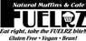 (360-337-1313) – Please allow at least 15 minutes for all phone orders to be ready for pick-up

Breakfast
Monday–Saturday 8:30-11:00
Mediterranean Breakfast Sandwich…11.94
G.F. or Bran bread with artichoke & sundried tomato spread, scrambled eggs. Topped with Tomato & Spinach. Served with fresh fruit.

Keto Scramble…………………………………..13.95
Scrambled eggs, Spinach, Mushroom, Onion, Tomato, Turkey Bacon, Bell pepper.
Texas Scramble…………………………………13.95
Scrambled eggs, Taco Meat, Tomato, Onion, Cheese and Avocado. Salsa on the side.
Bacon Egg Sandwich……………………….. 9.95
Bacon Egg Bagel………………………………… 9.84
Bagel and Cream Cheese…………………. 6.74
Avocado Toast……………………………………. 5.72 Sides
2 Slices bacon……………………………………….4.25
2 Slices G.F. or Organic Bran Toast…...3.95
2 Hard Boiled Eggs……………………………….3.12
Cheese or Avocado…………………………………1.75
2 slices of cheese, 3 slice avo. Seasonal.
Pesto or Mediterranean sauce………………..75
Fresh Seasonal Fruit Cup….…………..…….4.16
(360-337-1313) – Please allow at least 15 minutes for all phone orders to be ready for pick-up

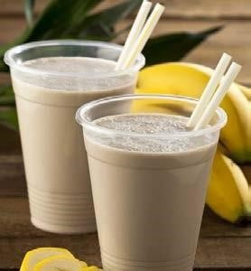

Kid’s Menu
Peanut Butter & Jelly Sandwich….……7.76
Full Peanut Butter & Jelly Sandwich served with Fresh
Fruit & Gluten/Dairy Free Popper.
Almond Butter & Jelly Sandwich.……7.76
Full Almond Butter & Jelly Sandwich served with Fresh
Fruit & Gluten Free PNB Popper.
Child’s Club Sandwich………….…………….8.23
½ Sandwich with Natural Turkey,Mayo, Cheddar Cheese,
Tomato & Lettuce. Served with Fresh Fruit &
Gluten Free PNB Popper.
Childs Smoothie…..……………………………….6.15
12oz. Strawberry & Banana. Add $0.50 for Non-Dairy
Green Apple Smoothie………………………….5.15
12oz. Apples, Organic Apple Juice, Green Grapes,
Spinach & Cinnamon..
Organic Juice ……..…................................3.12
V8 drink…………………………………………….1.82
LA Croax or Club Soda……………………1.40
Kombucha………………………………………….4.16
Bottled water……………………………………..1.30

Smoothies
20oz. Smoothies blended with Vegan Protein Powder All Ingredients can be modified to your preference
Misty’s Special……………………………………….8.25
Organic Spinach, Blueberries, Banana, Almond Milk
Apple Spice…………………………………………….8.50
Organic Apple, Grapes, Spinach, Cinnamon, Almond Milk
Pumpkin Spice……………………………………...8.25
Pumpkin, Apple, Ginger, Cloves, Cinnamon, Almond Milk
Chocolate Banana…………………………………8.25
100% Cacao, Banana, Berries, Turmeric, Rice Milk
Almond Butter Chocolate…………………....8.75
Almond Butter, 100% Cacao, Apple, Banana, Chia Seeds & Almond Milk
Peanut Butter Chocolate…………..………….8.75
Peanut Butter, 100% Cacao, Apple, Banana, Chia Seeds & Almond Milk
Green Smoothie……………………………………..8.75
Pineapple, Grapes, Organic Spinach, Coconut Milk
Optional Add-Ins…………………………....0.52/ea
Apple, Banana, Blueberry, Triple Berry, Pineapple,
Tropical Fruit, Carrot, Cucumber, Spinach, Almond
Butter, Peanut Butter, Flaxseed, Chia Seed
Power Up Add-Ins………………………...1.04/ea
MCT Oil, Green Zone, Collagen, BCAA Protein

(360-337-1313) – Please allow at least 15 minutes for all phone orders to be ready for pick-up
* ALL PRICES AND ITEMS SUBJECT TO CHANGE.

